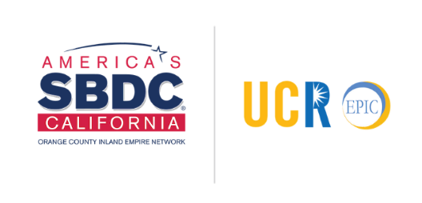
Learn about the SBIR/STTR Program & COVID-19 Funding
Presented by the University of California Riverside’s SBIR/STTR Resource Center
Friday, June 12, 2020 ● 10:00 a.m. to 11:00 PST
CLICK HERE to Register

The federal SBIR/STTR program is the leading resource for small businesses looking for commercialization and contracting support. SARS-CoV-2 (COVID-19) has resulted in a myriad of challenges and opportunities regarding screening, diagnostics, tracking, and treatment. Several federal agencies have published grant funding opportunity announcements (FOA) to (1) Model and understand the spread of COVID-19 (2) Inform & Educate: The science of virus transmission & prevention (3) Develop prevention & management processes and (4) Submit solution proposals: Screen, Diagnose, Treat, Find, Track.

This focused webinar reviews current COVID-19 announcements and proposal requests. What do we need to know about what is required to win these awards? What specific answers are they seeking? How can we facilitate an expedited submission and review of proposals? What are the decision criteria and pertinent parameters for this special funding? How much funding is allotted per FOA/RFP? What are review timeframes? How are payments accelerated to enable rapid solution research and development? How should you proceed? We will cover the following topics.

- Review of COVID-19 SBIR/STTR grant and contract FOAs; Agency Missions & Aims
  - Research Phase Processes: Funding Amounts Available per Phase
  - Applicant Eligibility Requirements; Size Rule; Grant and Contract Section Criteria
  - How to Start – Specifics of the Sequential Multi-Registration Process: Rules of the Road
- Specific Agency SBIRs - Responses to COVID-19
  - Areas of Research Being Funded and Specific Agency Interests
  - Accelerated Funding Protocols
  - Focused Proposal Requests
- How the Expedited Submission Processes work
  - Key guidelines and procedures for NSF proposals
  - How to Apply - Specific Timelines
- Proven Best Practices - Lessons Learned from Awardees
- How Industry, University, & Federal Partnerships Enhance Chances for Success
- Crucial, Overlooked Elements of the Proposal: Ignore at Your Peril
  - Key Reviewer Criteria Always Considered when evaluating your proposal
  - The Essentials of a Well-Prepared Project Description: Designing an Effective Study Approach
  - Your Commercialization Plan: Why It is Vital
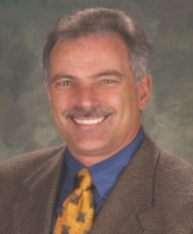
About the Speaker. This interactive workshop is given by serial entrepreneur Dr. Martin Kleckner. His ventures and clients have been awarded over $60 Million in federal agency and private funds during the past six years. He has worked with the highly-regarded Innovation Corps (NSF I-Corps; I-Corps at NIH) program at universities nationwide, is a lead mentor for the U C Riverside I-Corps and has more than 30 years of experience in senior level operations, general management, marketing, and business development. He serves as an Entrepreneur-in-Residence with the UC Riverside Office of Technology Partnerships and has been a reviewer for the NIH. In the last 4 years, he has advised start-ups in winning 16 SBIR grants.

The University of California Riverside’s SBIR/STTR Resource Center, in partnership with UCR’s EPIC SBDC and the Office of Technology Partnerships, offers small businesses comprehensive SBIR/STTR proposal support. The Center assists with the SBIR/STTR proposal submission process, development of a winning proposal, and connecting companies with UC Riverside.

Check out our website: https://sbir.ucr.edu/
UCR’s EPIC SBDC is funded in part through a Cooperative Agreement with the U.S. Small Business Administration. All opinions, conclusions, and/or recommendations expressed herein are those of the author(s) and do not necessarily reflect the views of the SBA. All programs are extended to the public on a nondiscriminatory basis.

