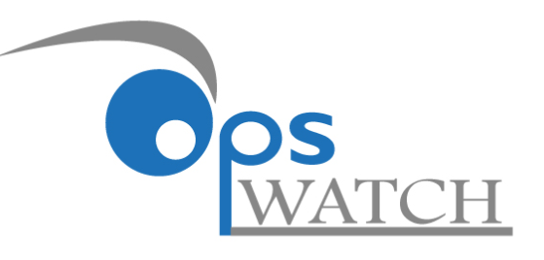

Presented by

Weekly COVID 19 Opportunities Update
New Opportunities
September 21, 2020

Table of Contents

Health Systems Capacity Building (including public health, telemedicine and mental health)

Department of Health and Human Services
Centers for Medicare & Medicaid Services
- Community Health Access and Rural Transformation (CHART)

Health Research Opportunities

Department of Health and Human Services
National Institutes of Health - Office of Research on Women’s Health
- Notice of Change: Expansion of Research Scope of RFA-OD-19-029 “The Intersection of Sex and Gender Influences on Health and Disease (R01 Clinical Trial Optional)"

Health Systems Capacity Building (including public health, telemedicine and mental health)

Department of Health and Human Services - Centers for Medicare & Medicaid Services - Community Health Access and Rural Transformation (CHART)
Proposal Due Date: May 17, 2021
Expected Number of Awards: 15
Estimated Total Program Funding: $75,000,000
Award Ceiling: $5,000,000
Award Floor:
Funding Opportunity Number: CMS-2G2-21-001

Purpose: The Community Health Access and Rural Transformation (CHART) Model is a voluntary payment model designed to meet the unique needs of rural communities. The CHART Model will test whether aligned financial incentives, increased operational flexibility, and robust technical support promote rural health care providers’ capacity to implement effective health care delivery system redesign on a broad scale. The Center for Medicare & Medicaid Innovation (CMMI) will evaluate the impact of the CHART Model on Medicare and Medicaid expenditures, access to care, quality of care, and health outcomes for rural residents.

CHART aligns with CMS’s Rethinking Rural Health initiative, which aims to ensure individuals in rural America have access to high quality, affordable health care by offering new and creative payment models. The CHART Model will include two tracks: 1) the Community Transformation Track and 2) the Accountable Care Organization (ACO) Transformation Track. This Notice of Funding Opportunity (NOFO) is for the Community Transformation Track only. Under the Community Transformation Track, award recipients will receive cooperative agreement funding and a programmatic framework to assess the needs of their Community (as defined in section A.4.3.1. Community Definition below) and implement health care delivery system redesign. Hospitals participating in the Community Transformation Track Alternative Payment Model (APM) will receive capitated payments. Capitated payments provide hospitals with a stable revenue stream and incentivize reductions in fixed costs and avoidable utilization. Operational flexibilities will be available for participating hospitals to relieve regulatory burden, emphasize high-value services, and support providers in care management for their beneficiaries.

https://www.grants.gov/web/grants/view-opportunity.html?oppId=329062

Health Research Opportunities

Department of Health and Human Services – Office of Research on Women’s Health - Notice of Change: Expansion of Research Scope of RFA-OD-19-029 “The Intersection of Sex and Gender Influences on Health and Disease (R01 Clinical Trial Optional)"
Proposal Due Date: November 2, 2020
Expected Number of Awards: 7
Estimated Total Program Funding: $3,000,000
Award Ceiling: 350,000 per year
Funding Opportunity Number: NOT-OD-20-168

Revised Language: ORWH is encouraging application submissions on the influence and intersection of sex and gender factors related to the SARS-CoV-2 virus or COVID-19 disease in alignment with RFA-OD-19-029.

Within the focus of RFA-OD-19-029, research topics of interest could include investigations of sex- and gender-related risk factors associated with COVID-19 disease prevalence, treatment and prevention, including the influence of co-morbid conditions. Studies examining the influence and intersection of sex and gender on COVID-19 related to health-seeking behaviors, access to health care, and health care systems are also within the scope of this funding opportunity

Applications submitted in response to this FOA are encouraged to consider populations of women that may be at higher risk for adverse COVID-19 outcomes due to: biological, physiological and genetic factors, cultural and socioeconomic factors such as education, sexual orientation, gender expression or identity, effects of poverty, access to care, quality of care, and access to opportunities for inclusion in clinical trials and studies. Of particular interest are NIH-designated health disparity populations, women living in underserved rural or urban settings, pregnant and lactating women, women who are frontline healthcare workers, or women who are incarcerated or with low socioeconomic status.

https://grants.nih.gov/grants/guide/notice-files/NOT-OD-20-168.html

